Ragtime Presentation
Name:
Due date:
Subject & Grade: Grade 7 Music
Unit Question: What happens when we change the beat, rhythm and timing?
AOI: Human ingenuity
Significant Concept: innovation and improvisation happen as a result of cultures coming together.
Approaches To Learning Skills Used: Information Literacy, Communication, Transfer

Your Task: Work in pairs to research and deliver a PowerPoint presentation about one aspect of Ragtime music.

Details & Conditions:
- You will be assigned a partner and a topic that is related to Ragtime music, such as: The Entertainer, Ragtime the musical, Scott Joplin, New Orleans Ragtime Orchestra, When I’m Sixty-four.
- Research about the topic using different sources, and acknowledge your sources using MLA format
- Create a 5-10 slide presentation that includes information, photos and samples of music to support your work. Ensure you use musical terminology in your presentation.
- Use Ragtime music features (melody, rhythm, timing, etc) to explain bullet point one above.

You will be assessed on the following MYP criteria:
Criterion A: Knowledge and understanding
Criterion C: Reflection (see attached sheet)

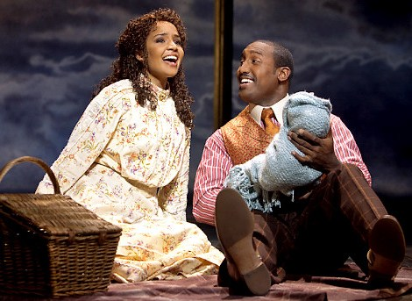

Criterion A: Knowledge and understanding

Achievement level | Descriptor Year 4  Students should be working towards…
0 | The student does not reach a standard described by any of the descriptors below.
1-2 | The student shows limited knowledge and understanding of the art form studied in relation to societal or cultural or historical or personal contexts.  The student is able to demonstrate limited knowledge and understanding of the elements of the art form studied.  The student is able to communicate a limited critical understanding of the art form studied, in the context of his or her own work.
3-4 | The student is able to demonstrate satisfactory knowledge and understanding of the art form studied in relation to societal or cultural or historical or personal contexts.  The student is able to demonstrate satisfactory knowledge and understanding of the elements of the art form studied.  The student is able to communicate satisfactory critical understanding of the art form studied, in the context of his or her own work although some opportunities are not pursued.
5-6 | The student is able to demonstrate good knowledge and understanding of the art form studied in relation to societal or cultural or historical or personal contexts.  The student is able to demonstrate good knowledge and understanding of the elements of the art form studied.  The student is able to communicate a good level of critical understanding of the art form studied, in the context of his or her own work.
7-8 | The student is able to demonstrate excellent knowledge and understanding of the art form studied in relation to societal or cultural or historical or personal contexts.  The student is able to demonstrate excellent knowledge and understanding of the elements of the art form studied.  The student is able to communicate a well developed critical understanding of the art form studied, in the context of his or her own work
Task-specific indicators:
- Show an understanding of the societal, cultural, historical and/or personal context of Ragtime music
- Show knowledge and understanding of the various elements of Ragtime

Student reflections:

Teacher comments:

Reflection Guidelines for your Developmental Workbook

Thing to consider on your reflection:
Did you learn anything new about Ragtime Music in this unit?
Did you learn anything new about yourself as a student or musician?
Do you think you improved you skills?
Looking at all your music experience, after this unit, have you changed or progressed? How?
Did you receive any feedback while working and how did you use it?
Do you prefer composing or performing? Why? How does knowing notation help you with your composing/performing?
What are some areas you would still like to improve on?

